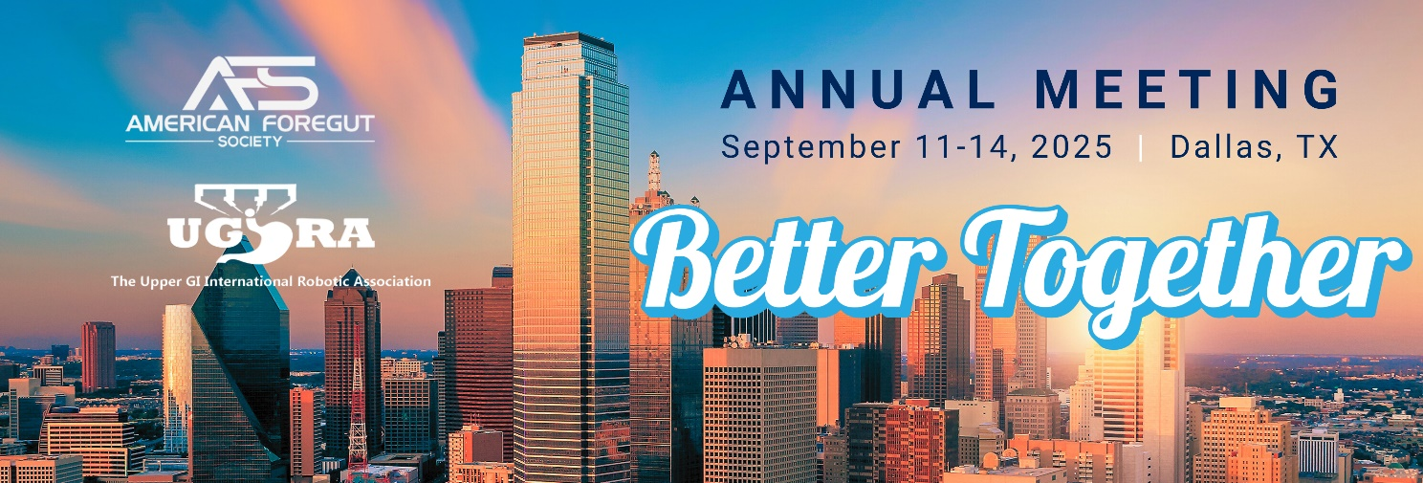

**AFS MEETING MESSAGING TOOLKIT**

In this resource, you'll find examples of social media posts/emails to help you promote the 2025 AFS Annual Meeting as one of our amazing speakers. ***Thank you for your support and promotion of this year’s Meeting. We are glad you are a part of it!***

**IMPORTANT DETAILS**

**Event Dates:** September 11 – 14, 2025

**Meeting Website:** <https://www.americanforegutsociety.org/2025-annual-meeting>

**Location:**

Gaylord Texan

1501 Gaylord Trail

Grapevine, Texas 76051

**SOCIAL MEDIA TIPS**

* Use the hashtags: **#AFS2025 #BetterTogether**
* Use an image or badge with your posts, you will be provided with a few different images to share.
* Share what you are most looking forward to at the event, include a highlight from the list shared below.
* Customize the language to fit your style.

**AFS SOCIAL ACCOUNTS**

|  |  |  |  |
| --- | --- | --- | --- |
| F:\AmSECT\Instagram_AppIcon_Aug2017.png |  |  |  |
| [@americanforegut](https://www.instagram.com/americanforegut/) | [@AmericanForegutSociety](https://www.facebook.com/Americanforegutsociety/) | [@AmericanForegutSociety](https://www.linkedin.com/company/american-foregut-society/) | [@foregutsociety](https://twitter.com/foregutsociety) |

**MEETING MESSAGING EXAMPLES – SOCIAL**

* Registration for the AFS Annual Meeting is open! Join me in Dallas at the Gaylord Texan, September 11-14, and don’t miss your chance to connect with the foregut community & hear from industry experts! Learn more about this year’s Meeting and register here: <https://www.americanforegutsociety.org/2025-annual-meeting>
* Excited to be speaking at the 2025 AFS Annual Meeting this September in Dallas! I’ll be presenting on [insert session topic], alongside colleagues who are pushing the boundaries in foregut care.

If you haven’t registered yet, now’s the time.

📍 Dallas, TX | 📅 Sept 11–13

🔗 <https://www.americanforegutsociety.org/2025-annual-meeting>

Let’s keep advancing the field—together. #AFS2025

* AFS is dedicated to offering continued education, support and advocacy for the Foregut community. That’s why I am excited to attend the AFS Annual Meeting, in beautiful Dallas, Texas. Learn more and register now: <https://www.americanforegutsociety.org/2025-annual-meeting>
* Join me and the incredible AFS community at the AFS Annual Meeting, September 11-14 in Dallas! From engaging sessions to networking opportunities, this year’s event has everything you need to elevate your career.

💡 Whether you're a seasoned professional or just getting started on your journey, this event is packed with something for everyone. I hope to see you there!

📅 Save your spot now: <https://www.americanforegutsociety.org/2025-annual-meeting>

* I’m excited to head to **#AFS2025** this September in Dallas! I’ll be joining colleagues from across GI and foregut surgery for hands-on learning, great discussions, and a few surprises. Hope to see you there! <https://www.americanforegutsociety.org/2025-annual-meeting>
* Join me at the 2025 AFS Annual Meeting for **[insert session title or topic]**! I’m looking forward to sharing insights and connecting with the foregut care community in Dallas.

📍 Gaylord Texan | 📅 September 11–13

Registration is open: <https://www.americanforegutsociety.org/2025-annual-meeting>

* I’ve learned more, connected more, and grown more through AFS than almost any other meeting I attend. That’s why I’m making my way to Dallas this fall for the **2025 AFS Annual Meeting**. The sessions are top-tier, the post-graduate courses are truly hands-on, and the conversations with peers always spark something new. If you’re on the fence about attending—this is your sign. Let’s meet where foregut care moves forward! <https://www.americanforegutsociety.org/2025-annual-meeting>

**MEETING MESSAGING EXAMPLES - EMAIL**

**EMAIL OR NEWSLETTER ITEM 1**

**Headline:** Registration is open for the 2025 AFS Annual Meeting!

**Body:** ***[I/We/Company are/am]*** are a proud **[speaker/presenter]** at the 2025 AFS Annual Meeting! Join us in Dallas, September 11-14, 2025 for four days of expert-led education, hands-on learning, and collaboration across the foregut community.

Whether you're a foregut surgeon, gastroenterologist, or researcher, this meeting offers practical takeaways and meaningful connection—with a special collaboration day with UGIRA on **September 13**.

***<INSERT ANY ADDITIONAL DETAILS RE: YOU/YOUR ORGS INVOLVEMENT>***

**Closing and link**: ***[I/We/Company are/am]*** hope to see you there! Registration and details can be found here: <https://www.americanforegutsociety.org/2025-annual-meeting>

**EMAIL OR NEWSLETTER ITEM 2**

**Headline:** Join us at the 2025 AFS Annual Meeting!

**Body:** Get ready for an exceptional experience in Dallas at the **2025 American Foregut Society Annual Meeting**! Join **[*me/us/company]*** from **September 11–13, 2025**, with optional **post-graduate courses available on September 10, 11, and 14**, for high-impact education, collaborative discussion, and hands-on learning that’s driving the future of foregut care.

Annual Meeting Highlights/What to expect:

#1

#2

#3

***<INSERT ANY ADDITIONAL DETAILS RE: YOU/YOUR ORGS INVOLVEMENT>***

It’s not too late to register for the 2025 AFS Annual Meeting. Join ***[Me/Us/Company]*** in Dallas and be part of the momentum moving foregut care forward.

**Closing and link:** See you there: <https://www.americanforegutsociety.org/2025-annual-meeting>