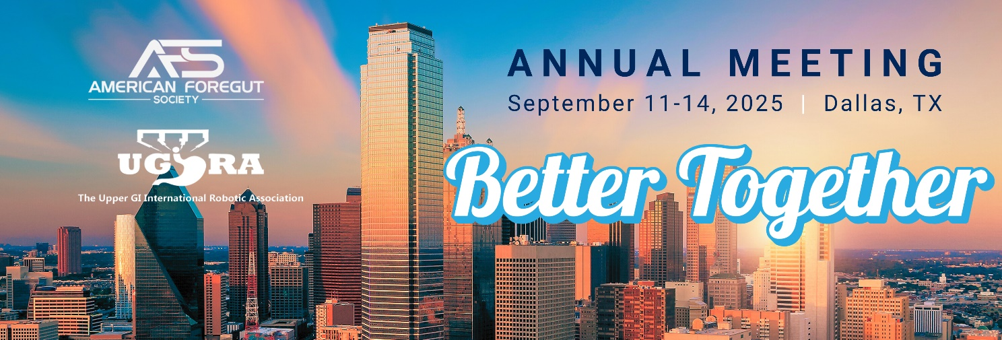

**AFS MEETING MESSAGING TOOLKIT**

In this resource, you'll find examples of social media posts/emails to help you promote the 2025 AFS Annual Meeting as one of our trusted partners. ***Thank you for your support and promotion of this year’s Meeting. We are glad you are a part of it!***

**IMPORTANT DETAILS**

**Event Dates:** September 11 – 14, 2025

**Meeting Website:** <https://www.americanforegutsociety.org/2025-annual-meeting>

**Location:**

Gaylord Texan

1501 Gaylord Trail

Grapevine, Texas 76051

**SOCIAL MEDIA TIPS**

* Use the hashtags: **#AFS2025 #BetterTogether**
* Use an image or badge with your posts, you will be provided with a few different images to share.
* Share what you are most looking forward to at the event, include a highlight from the list shared below.
* Customize the language to fit your style.

**AFS SOCIAL ACCOUNTS**

|  |  |  |  |
| --- | --- | --- | --- |
| F:\AmSECT\Instagram_AppIcon_Aug2017.png |  |  |  |
| [@americanforegut](https://www.instagram.com/americanforegut/) | [@AmericanForegutSociety](https://www.facebook.com/Americanforegutsociety/) | [@AmericanForegutSociety](https://www.linkedin.com/company/american-foregut-society/) | [@foregutsociety](https://twitter.com/foregutsociety) |

**MEETING MESSAGING EXAMPLES – SOCIAL**

* Registration for the AFS Annual Meeting is open! Join me in Dallas at the Gaylord Texan, September 11-14, and don’t miss your chance to connect with the foregut community & hear from industry experts! Learn more about this year’s Meeting and register here: <https://www.americanforegutsociety.org/2025-annual-meeting>
* AFS is dedicated to offering continued education, support and advocacy for the Foregut community. That’s why we are excited to attend the AFS Annual Meeting, in beautiful Dallas, Texas. Learn more and register now: <https://www.americanforegutsociety.org/2025-annual-meeting>
* Join us and the incredible AFS community at the AFS Annual Meeting, September 11-14 in Dallas! From engaging sessions to networking opportunities, this year’s event has everything you need to elevate your career.

💡 Whether you're a seasoned professional or just getting started on your journey, this event is packed with something for everyone. We hope to see you there!

📅 Save your spot now: <https://www.americanforegutsociety.org/2025-annual-meeting>

* We’re proud to support the 2025 AFS Annual Meeting!

Stop by our booth **[INSERT BOOTH #]** in Dallas to connect, explore new solutions, and join the conversation around advancing foregut care.

📍 Gaylord Texan | 📅 September 11–13

🔗 Register today: <https://www.americanforegutsociety.org/2025-annual-meeting>

* Have you registered for the 2025 AFS Annual Meeting yet?  
  Whether you're focused on clinical innovation, surgical technique, or expanding your foregut network, this year’s meeting delivers the education and connections that matter.

We’ll be there—will you?  
📅 September 11–13 | 📍 Dallas, TX  
🔗 Register now:

<https://www.americanforegutsociety.org/2025-annual-meeting>

* **[We/Company]** are excited to be attending the 2025 AFS Annual Meeting on **[insert day]**! Catch us at Booth **[insert booth number]**—we’re looking forward to connecting with the foregut community and supporting innovation in care.

Don’t miss it—register here:<https://www.americanforegutsociety.org/2025-annual-meeting>

**MEETING MESSAGING EXAMPLES - EMAIL**

**EMAIL OR NEWSLETTER ITEM 1**

**Headline:** Registration is open for the 2025 AFS Annual Meeting!

**Body:** ***[I/We/Company are/am]*** are a proud **[sponsor of/exhibitor at]** the 2025 AFS Annual Meeting! Join us in Dallas, September 11-14, 2025 for four days of expert-led education, hands-on learning, and collaboration across the foregut community.

Whether you're a foregut surgeon, gastroenterologist, or researcher, this meeting offers practical takeaways and meaningful connection—with a special collaboration day with UGIRA on **September 13**.

***<INSERT ANY ADDITIONAL DETAILS RE: YOUR ORGS INVOLVEMENT>***

**Closing and link**: ***[We/Company are/am]*** hope to see you there! Registration and details can be found here: <https://www.americanforegutsociety.org/2025-annual-meeting>

**EMAIL OR NEWSLETTER ITEM 2**

**Headline:** Join us at the 2025 AFS Annual Meeting!

**Body:** Get ready for an exceptional experience in Dallas at the **2025 American Foregut Society Annual Meeting**! Join **[*us/company]*** from **September 11–13, 2025**, with optional **post-graduate courses available on September 10, 11, and 14**, for high-impact education, collaborative discussion, and hands-on learning that’s driving the future of foregut care.

Annual Meeting Highlights/What to expect:

#1

#2

#3

***<INSERT ANY ADDITIONAL DETAILS RE: YOUR ORGS INVOLVEMENT>***

It’s not too late to register for the 2025 AFS Annual Meeting. Join ***[Us/Company]*** in Dallas and be part of the momentum moving foregut care forward.

**Closing and link:** See you there: <https://www.americanforegutsociety.org/2025-annual-meeting>